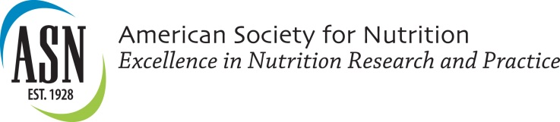

News Release Template

[Name] Recognized as a Finalist in Emerging Leaders in Nutrition Science Competition

[City, State] – February 23, 2015 – [Name] has been named a finalist in the American Society for Nutrition’s (ASN) Emerging Leaders in Nutrition Science Competition, a new program to recognize the highest quality research presented by students and young investigators at ASN’s Scientific Sessions and Annual Meeting at Experimental Biology 2015.

More than 1,000 abstracts were submitted by students and postdoctoral fellows and the Emerging Leaders in Nutrition Science Competition aims to recognize the top 20% highest scoring abstracts as finalists. Abstracts were rated by more than 200 nutrition scientists.
[Mr./Ms./Dr.] [Last Name’s] abstract is titled [Abstract Title].

All finalists will compete in a poster competition to be held Saturday, March 28 from 5:00 – 7:00 pm in Ballroom East of the Boston Convention and Exhibition Center. Grand prize winners in more than 16 topical categories will be identified and receive travel awards.

The Emerging Leaders in Nutrition Science Competition is being organized by ASN’s Research Interest Sections, Global Nutrition Council and Medical Nutrition Council and sponsored by PepsiCo.
For a full list of finalists in the Emerging Leaders in Nutrition Science Competition, visit scientificsessions.nutrition.org/special_events/emerging-leaders.

The American Society for Nutrition is the authoritative voice on nutrition and publisher of The American Journal of Clinical Nutrition, The Journal of Nutrition, and Advances in Nutrition. Established in 1928, ASN’s more than 5,000 members in more than 75 countries work in academia, practice, government and industry. ASN advances excellence in nutrition research and practice through its publications, education, public affairs and membership programs. Visit us at www.nutrition.org.
###

